Execution of inputs :(0,0);(1,1);(2,3);(5,2);(3,4)

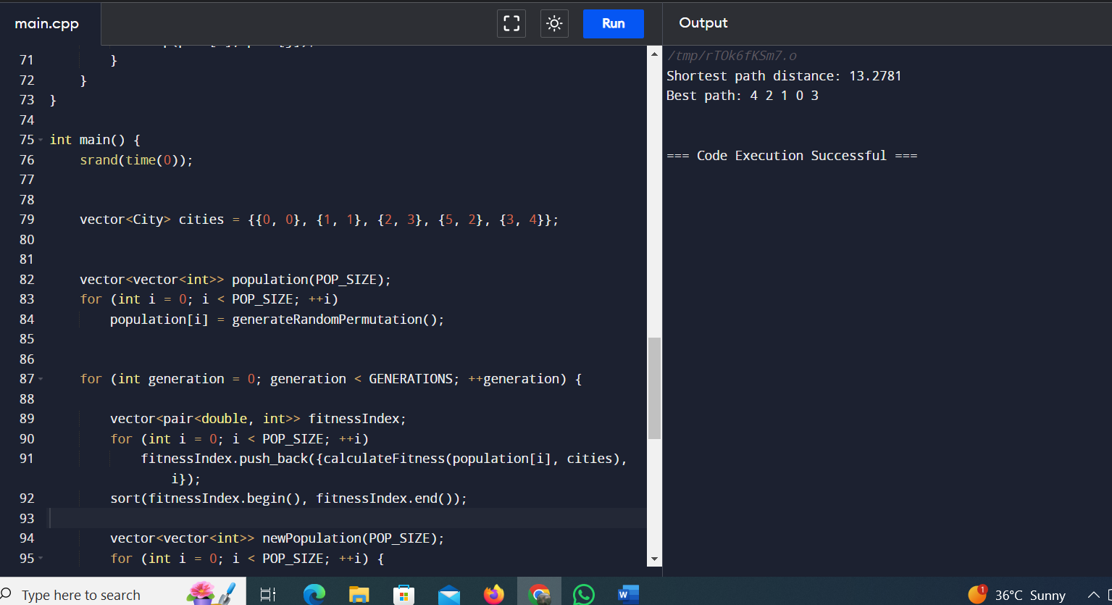

2 nd input:(0,0);(1,2);(2,4);(5,2);(3,4)

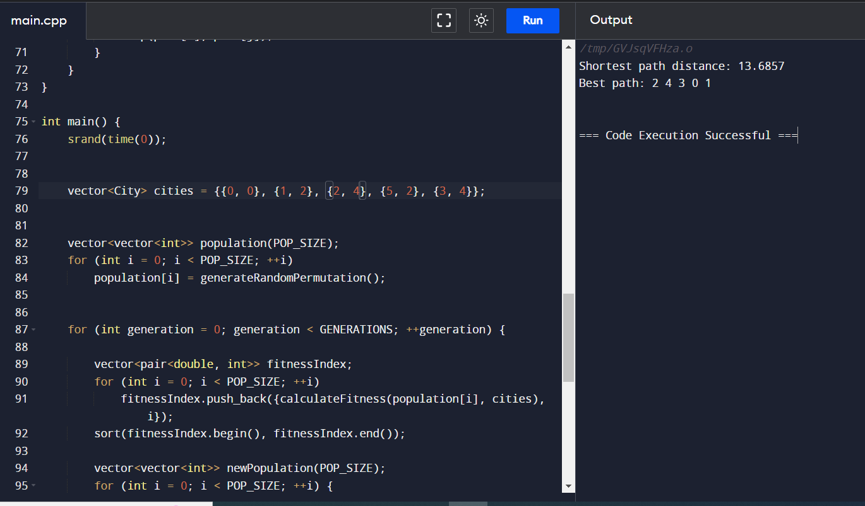

3rd input:(0,0);(1,1);(2,3);(5,5);(3,3)

